**FAST NUCES**

*Lahore Campus*



**Group Assignment**

**Name:**

Hina Urooj Malik

**Course Title:**

Deep Learning

**Topic:**

Sentimental Analysis on Movie Reviews

**Program:**

MSCS

**Table of Contents**

Abstract 3

Introduction 4

Literature Review 6

Implementation 9

Experimental Results 10

Conclusion 13

References 14

# Abstract

In today’s era of social media, sentiment analysis has become indispensable for comprehending and categorizing the vast amount of daily data, offering a powerful tool for deciphering people’s emotions and attitudes expressed through written text. Employing

advanced technologies such as data mining, machine learning, and artificial intelligence,

sentiment analysis not only distinguishes between positive, negative, and neutral expressions.

but also provides nuanced insights into the intensity, subjects, and expressors of emotions.

The film industry benefits from sentiment analysis, using it to categorize movie reviews. based on language use. We use neural networks to analyze the training and testing datasets in our IMDB dataset. After that, we use NN to apply Recurrent NN – LSTM to evaluate the performance.

# Introduction

Social media is now a significant part of our lives. People love to share everything on platforms like Facebook and Instagram, from pictures to opinions on trending topics, politics, and movie reviews. Due to the enormous amount of data and opinions being produced, shared, and transferred every day across the internet and other media, sentiment analysis has become vital for developing opinion mining systems.

Sentiment analysis, also called opinion mining, is like a super tool for understanding how people feel in written words. It is the analysis of people's opinions, emotions, and attitudes from written expressions. Nowadays, individual users have shown great interest in opinions about products and services on the web, and this information largely affects user decisions.

In addition to individuals, analyzing consumer sentiment is an important way for companies to be aware of how their products and services are perceived. It's used by companies to figure out if people like or dislike their products, services, or ideas. This tool works by using smart technology like data mining, machine learning, and artificial intelligence to read and understand text. It can tell if the words used are positive, negative, or just neutral.

Companies use sentiment analysis to get quick insights into what customers are feeling right now and how they view the company. The tool looks at all kinds of online stuff like emails, blog posts, reviews, and social media comments. It uses smart algorithms to figure out if the words used are positive, negative, or neutral.

But sentiment analysis goes beyond just identifying feelings. It can also tell how strong these feelings are, who or what the feelings are about, and who is expressing them. It's like reading between the lines of what people write to understand more about what they really mean.

Businesses using these tools can keep a close eye on what customers are saying and quickly respond to any changes in opinions. Sentiment analysis is like a superhero for businesses, helping them stay on top of what people are saying and making smart moves based on those feelings.

A movie review is like a story where someone shares their thoughts about a movie, saying if it's good or bad. These reviews can impact the people who made the movie. Some research shows that a movie can do well or fail based on what people say about it. So, it's important to sort these reviews into positive or negative ones. This sorting is done by looking at the words used in the reviews and checking if they were used in a good or bad way before. This helps us understand what people like or don't like about a movie. Sentiment Analysis (SA) is like a tool that helps with this. But, figuring out how people feel about movies is not easy. Movie reviews can be very different in how long they are, how they are written, and the words used. Sometimes, people use tricky or funny words that are hard for machines to understand. Also, movie reviews often talk about things only people who know a lot about movies understand. To handle these challenges, researchers use different methods. Some use rules or dictionaries to decide if a review is positive or negative. These are quick but not very flexible. Others use machine learning, where computers learn from lots of movie reviews to figure out how to sort them automatically. This way is more flexible but needs more data and power. They use techniques like support vector machines, decision trees, and neural networks to make sense of the reviews.

Due to the massive data evolution and the amount of data being exchanged and produced every second and as people post more and more text information on the internet, the urge to comprehend, mine, and analyze this data has remarkably increased. It has been a great challenge to distinguish whether the information is useful or not. As a result, it's very urgent to develop language models to dig out valuable information; specifically, for product reviews, mining useful product review information may help merchants develop sales strategy effectively.

Artificial intelligence has become an area with many practical applications and active research topics and is booming. Artificial intelligence systems need to have the ability to acquire knowledge themselves, which is the ability to extract patterns from raw data. This ability is called machine learning. Deep learning is a kind of machine learning. It is a technology that can make computer systems improve from experience and data. It is one of the ways to lead to artificial intelligence. In the development of the past few decades, deep learning has borrowed a lot of knowledge from the human brain, statistics, and applied mathematics. In recent years, with the increasing amount of data and the rapid development of computers, there are varieties of big data issues. Then, the practicality of deep learning is gradually improving, such as in the fields of speech and image recognition and so on.

Deep learning networks learn the features on their own; that is, it has become apparent as a robust machine learning technique that learns multiple layers of features of the data and induces results of prediction. Deep learning has been recently used in various applications in the field of signal and information processing, especially with the evolution of big data. In addition, deep learning networks have been used in sentiment analysis and opinion mining.

# Literature Review

Dian Li et al. proposed an RNN language model based on Long Short-Term Memory (LSTM) as it is better at analyzing the emotion of long sentences. Their experiments focused on classification problems with two or three categories. They utilized four sets of data: two types of comments from JD.COM, travel comments from Ctrip, and English movie reviews. Among them, comments from JD.COM and travel comments from Ctrip are in Chinese. After data cleaning, one type of comments from JD.COM is classified into three categories:

positive, neutral, and negative emotion. The other type of comments from JD.COM, travel comments from Ctrip, and English movie reviews are classified into two categories: positive and negative emotion. They employed 10 unfold layers in the BPTT algorithm to train the weights, as LSTM requires fewer unfold layers to achieve better results. The results indicate that RNN with LSTM can achieve a higher accuracy rate and recall rate than conventional RNN. It specifically identifies long statements and statements containing conjunctions better than conventional RNN. Therefore, by training this emotion model, they have achieved multi-classification for text emotional attributes, allowing them to determine the emotion to which a sentence belongs. [1]

Hassan et al. have proposed ConvLstm, a neural network architecture that employs CNN (to extract high-level features from the input sequence) and LSTM (to remember important information across long stretches of time) on top of pre-trained word vectors trained on 100 billion words from Google News. They validated the proposed model on two sentiment datasets: IMDB and Stanford Sentiment Treebank (SSTb). The IMDB dataset consists of 50,000 binary labeled reviews, and SSTb consists of 11,855 reviews from Rotten Tomatoes. The number of epochs varies between 5 and 10 for both datasets. They used multiple filters with width, feature maps = 256, ReLUs for nonlinearity, and applied dropout of 0.5 only before the recurrent layer. For training, stochastic gradient descent over shuffled mini-batches was used, and the model was trained by minimizing the negative log-likelihood or crossentropy loss. The gradient of the cost function is computed with backpropagation through time (BPTT). These vectors were trained on 100 billion words from Google News, and the word2vec tool is publicly available. Comparable results were achieved with a smaller number of convolutional layers compared to the convolutional-only architecture. [2]

Cen et al. have introduced three deep learning models (CNN, RNN, and LSTM) and compared the results with those of SVM and RNTN. They used Baidu’s PaddlePaddle deep learning framework to conduct experiments, a very popular framework in deep learning. These models were applied to the IMDB dataset with 50% positive reviews and 50% negative reviews, totaling 50,000 reviews from the online movie database, with a 1:1 ratio for training and testing sets. The three models reached a steady state after 180 steps. The results showed that CNN reported an accuracy of 88.22%, while RNN and LSTM reported accuracies of 68.64% and 85.32%, respectively. The experimental results demonstrate that CNN has a good effect on the problem of text classification. [3]

Harish et al. have shown that when testing against classifiers like SVM, Naïve Bayes, KNN, and Maximum Entropy, the use of hybrid feature extraction obtained by concatenating machine learning features with lexicon features gives better results both in terms of accuracy and complexity. They used IMDb as a dataset, containing 25,000 positive and negative reviews each. However, due to limitations in computational resources, they randomly chose 5,000 reviews for experimentation. The sentiment analysis task is carried out in the following phases: preprocessing the dataset, feature extraction (both statistical and lexicon approaches), feature selection, and finally, classification using hybrid features. For experimentation, a 5fold validation technique has been used. Initially, machine learning features were highdimensional in nature, but to reduce them, feature selection methods such as Information Gain, Correlation, Chi Square, and RLPI are used. On the other hand, lexicon-based features such as Positive Word Count (PC), Negative Word Count (NC), Positive Connotation Count (PCC), and Negative Connotation Count (NCC) are extracted. Maximum Entropy with correlation shows the best results in terms of both accuracy and F-measure when compared to other classifiers. Thus, the results obtained are highly promising both in terms of space complexity and classification accuracy. In future work, more lexicon features will be included in the feature subset, expecting to increase the classification accuracy. [4]

Nehal et al. introduced four deep learning networks (MLP, CNN, LSTM and CNN_LSTM).

They used IMDB dataset, consisting of 50K movie reviews (25K positive reviews files and 25K negative review files), all written in English. The dataset has been divided into 80% training set and 20% testing set. The steps included loading the dataset, applying preprocessing procedures; then the result is processed by a convolutional layer, Maxpooling has been applied afterwards. Following that, the LSTM layer has processed the data and finally the output of classified reviews is produced. This workflow represents only the hybrid CNN_LSTM model. The results have shown that CNN_LSTM reported an accuracy of

89.2%, while CNN achieved accuracy of 87.7%. MLP and LSTM reported accuracies of 86.74% and 86.64, respectively. Moreover, the results have elaborated that the proposed deep learning models have also outperformed SVM, Naïve Bayes and RNTN which were published in other works using English datasets. [5]

Haque et al. compared CNN, LSTM, and LSTM-CNN architectures for sentiment classification on IMDb movie reviews. They utilized the IMDb dataset, which includes 50,000 movie reviews classified as positive or negative. The dataset was divided into a 70:30 ratio for training and testing, with 20% of the training samples used as validation data. For CNN, the model was trained for 8 epochs with a batch size of 128, while LSTM was trained for 5 epochs with the same batch size, and LSTM-CNN for 6 epochs. The observation indicated that CNN outperformed LSTM and LSTM-CNN, emphasizing that syntax is less crucial than positive or negative sentiment in classification. Both LSTM and LSTM-CNN also exhibited superior performance compared to the traditional method used for sentiment classification on the IMDb movie review dataset. The authors concluded that CNN is the most suitable architecture for sentiment classification on IMDb movie reviews, achieving a 2% higher accuracy than LSTM and 1% higher than LSTM-CNN. CNN obtained an F-Score of 91%, surpassing other state-of-the-art approaches in sentiment classification on the IMDb dataset. For future work, the authors plan to employ convolutional neural networks in other areas of natural language processing and assess their performance in those domains. [6]

Borele et al. have reviewed machine learning-based approaches to sentiment analysis, highlighting their salient features. To address limitations in some techniques, their study focuses on machine learning approaches, specifically the use of Artificial Neural Networks (ANN) in sentiment classification and analysis. The core dataset comprises 50,000 movie reviews evenly split into 25k training and 25k test sets. The distribution of labels is balanced (25k positive and 25k negative), and an additional 50,000 unlabeled documents are included for unsupervised learning. Preprocessing steps involve stop word removal, symbol removal, and POS tagging (Part of Speech). The feature extraction method identifies features (adjectives) in the dataset. These adjectives are then used to indicate positive and negative polarity in a sentence, aiding in determining individuals' opinions/sentiments using a unigram model. In the proposed system, ANN is employed for sentiment classification. Weights are assigned to each comment in the training phase, and fuzzy logic is applied to address negations like "not" and "never." This approach helps improve accuracy in terms of correlations and dependencies. The study suggests that implementing ANN would result in enhanced classification by combining the strengths of artificial neural networks with fuzzy logic. [7]

# Implementation

**Tools and Libraries:**

* **Mathematical/ Plotting Libraries** o Pandas o Numpy o Matplot o Seaborn o Plotly
* **Natural Language processing** o Re (regex) o Nltk o Wordcloud
* **Deep Learning** o Keras

**Code structure**

* **Data processing:**

o **Load data** (using .csv file)o **Data Analysis:** Analyze the type of data and labels using pandas data frameo **Data Visualization:** data visualized using different plots using seaborn and

Matploto **Data Cleaning:** removing duplicates/null values, break tags and links

* **Data Spitting:** Split the datainto trainig and testing using sklearn library
* **Prepare Sequential Neural Networks** o **Model training:** Using different optimizers as rms and adams o **Model Evaluation:** Evaluate the model on unseen/test dataset
* **Prepare Sequential Recurrent Neural Networks - LSTM** o **Model training:** Using different optimizers as adams o **Model Evaluation:** Evaluate the model on unseen/test dataset
* **Conclusions** o The model was trained using various hyper-parameters. to attain optimal training and ensuing testing precision. After evaluating the model with various combinations of hyperparameters, we found that the hyperparameter we used to train our model produced the best outcomes.

# Experimental Results

**For Neural Networks**

**Graphs for RMS Optimizer**

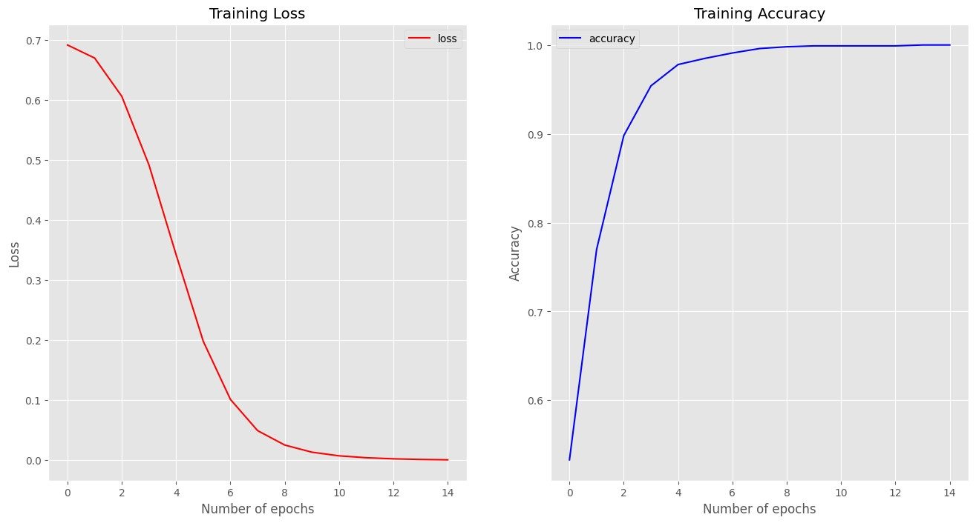

**Graph of Adam Optimizer**

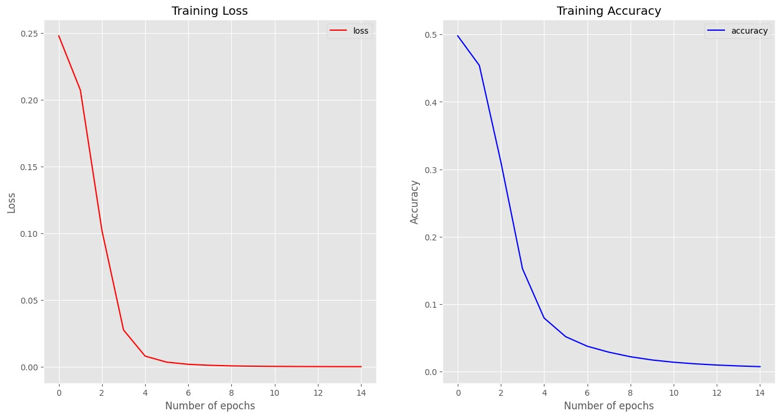

**For Recurrent Neural Networks**

**For Adam Optimizer for Training Loss**

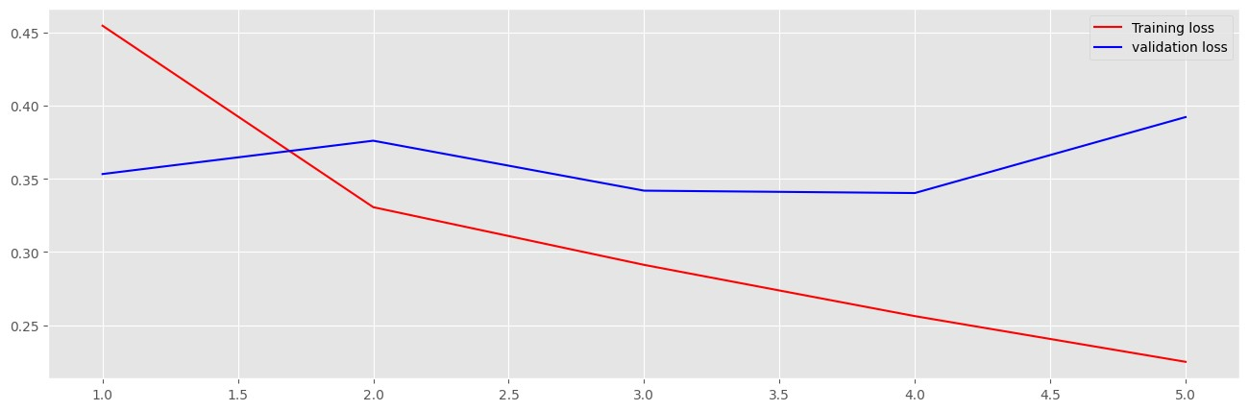

**For Adam Optimizer for Training Accuracy**

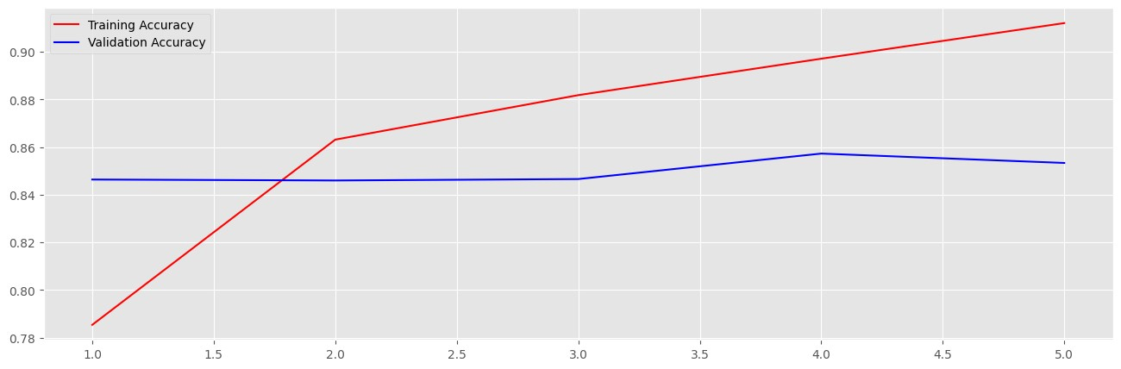

# Conclusion

In summary, sentiment analysis proves to be a crucial instrument for comprehending the rapidly growing field of digital communication. A variety of approaches are presented in the

literature review, ranging from conventional models like SVM to sophisticated deep learning

architectures like CNN and LSTM. These models show impressive accuracy in extracting sentiments from a variety of datasets, especially when used in hybrid forms. The study

highlights the usefulness of sentiment analysis in a variety of contexts, from private social

media comments to important customer perception data for enterprises. Even though artificial

intelligence (AI), and deep learning in particular, has advanced the area, issues like linguistic variety and contextual nuances still exist. Going forward, the emphasis should be on

improving current models and investigating creative solutions to these problems. Sentiment

analysis has the power to fundamentally alter how we perceive public opinion and enable well-informed decision-making. Sentiment analysis is still a dynamic field with broad societal consequences that affects consumers, corporations, and researchers equally as data grows and technology advances.

# 

# References

1. Li, Dan, and Jiang Qian. "Text sentiment analysis based on long short-term memory." *2016 First IEEE International Conference on Computer Communication and the Internet (ICCCI)*. IEEE, 2016.
2. Hassan, Abdalraouf, and Ausif Mahmood. "Deep learning approach for sentiment analysis of short texts." *2017 3rd international conference on control, automation and robotics (ICCAR)*. IEEE, 2017.
3. Cen, Peng, Kexin Zhang, and Desheng Zheng. "Sentiment analysis using deep learning approach." *J. Artif. Intell* 2.1 (2020): 17-27.
4. Harish, B. S., Keerthi Kumar, and H. K. Darshan. "Sentiment analysis on IMDb movie reviews using hybrid feature extraction method." (2019).
5. Ali, Nehal Mohamed, Marwa Mostafa Abd El Hamid, and Aliaa Youssif. "Sentiment analysis for movies reviews dataset using deep learning models." *International Journal of Data Mining & Knowledge Management Process (IJDKP) Vol* 9 (2019).
6. Haque, Md Rakibul, Salma Akter Lima, and Sadia Zaman Mishu. "Performance analysis of different neural networks for sentiment analysis on IMDb movie reviews." *2019*

*3rd International conference on electrical, computer & telecommunication engineering (ICECTE)*. IEEE, 2019.

1. Borele, Pranali, and Dilipkumar A. Borikar. "An approach to sentiment analysis using artificial neural network with comparative analysis of different techniques." *IOSR Journal of Computer Engineering (IOSR-JCE)* 18.2 (2016): 64-69.